2022

Rishi Suri

ROLL NO-1802447

5/23/2022

IOT PRACTICAL FILE

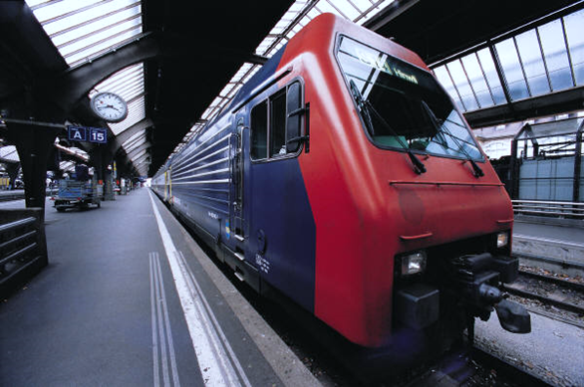

IOT PRACTICAL FILE

EXPERIMENT-NO.1

LED BLINKING

DIAGRAM

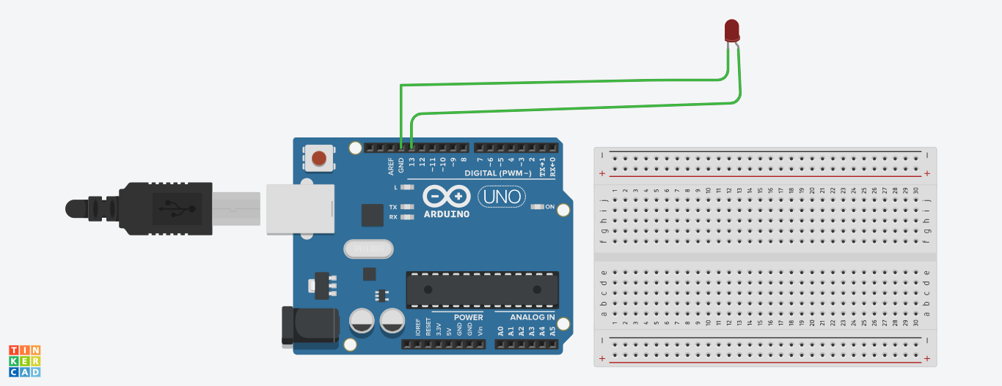

Code:-

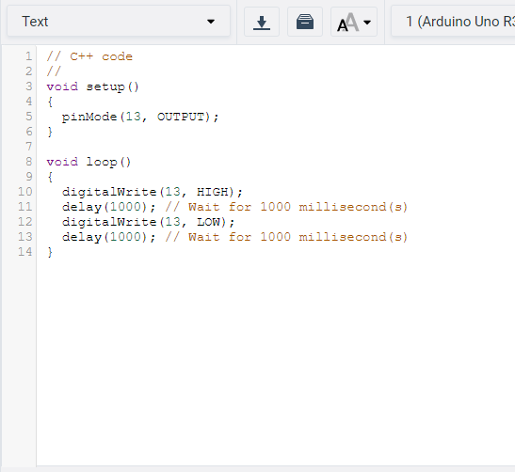

EXPERIMENT-2

DOUBLE LED’s BLINKING

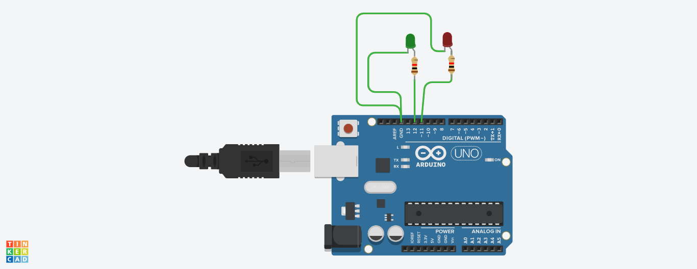

CODE:-

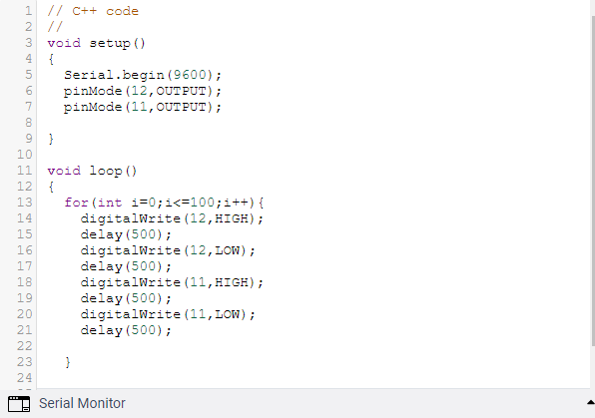

EXPERIMENT-3

TRIPPLE LED BLINKING

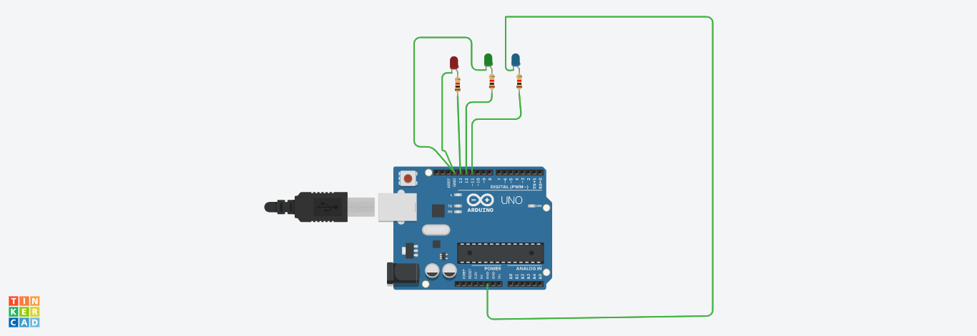

Code:-

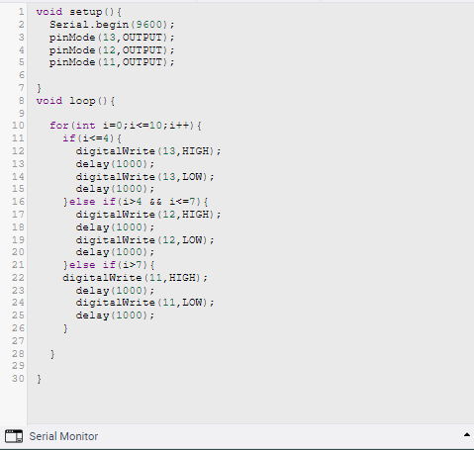

EXPERIMENT-4

LED’s WITH PUSH BUTTON CONTROL

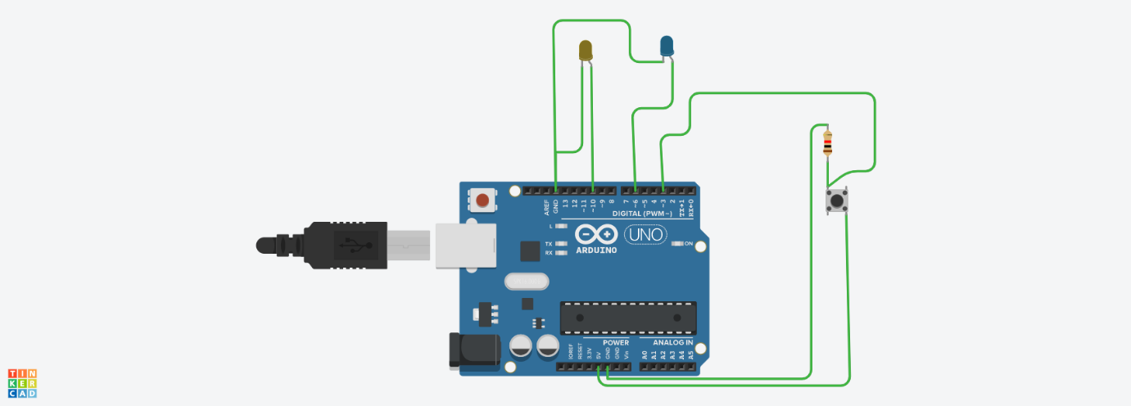

CODE:-

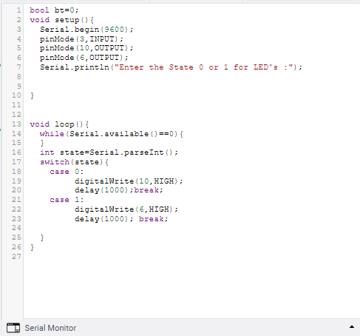

EXPERIMENT-5

Temperature sensor with multiple LED's and Buzzer

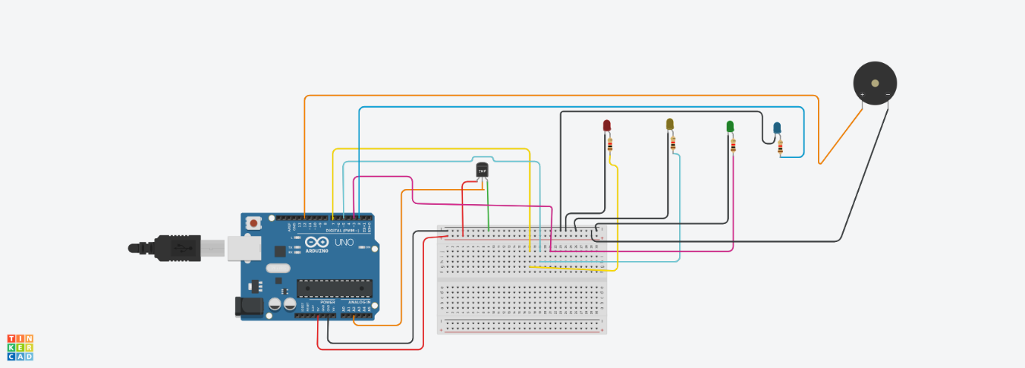

CODE:- 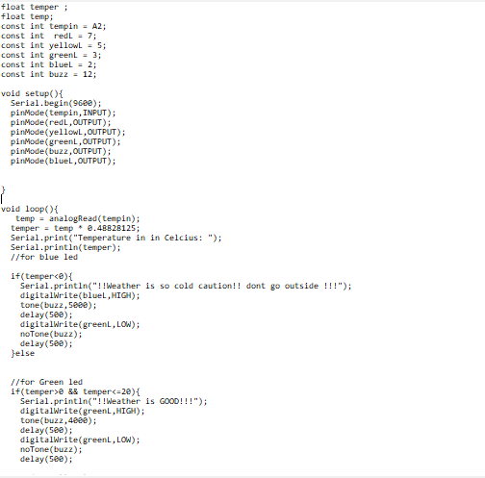

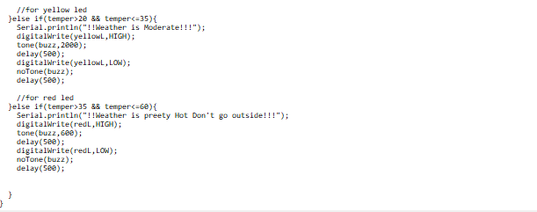

EXPERIMENT-6

Servo Motor

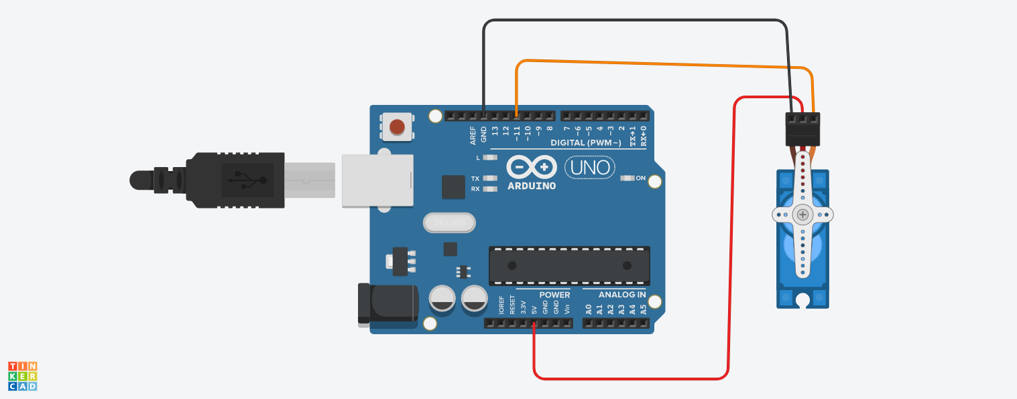

CODE:-

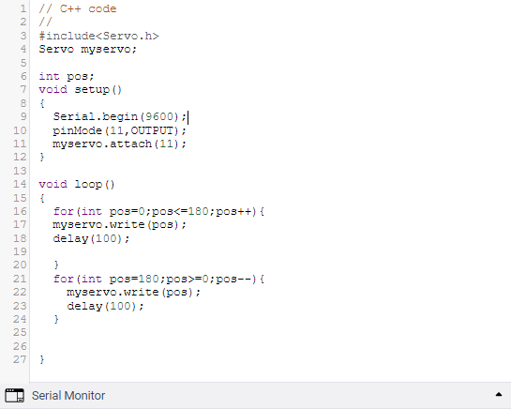

EXPERIMENT-7

Servo motor with Potentiometer

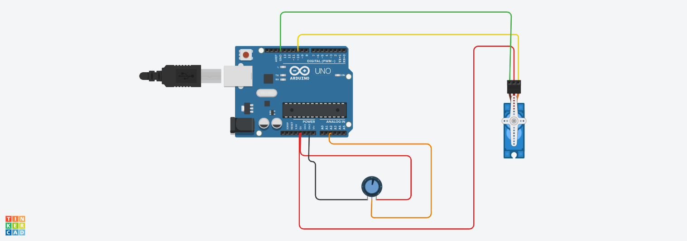

CODE:-

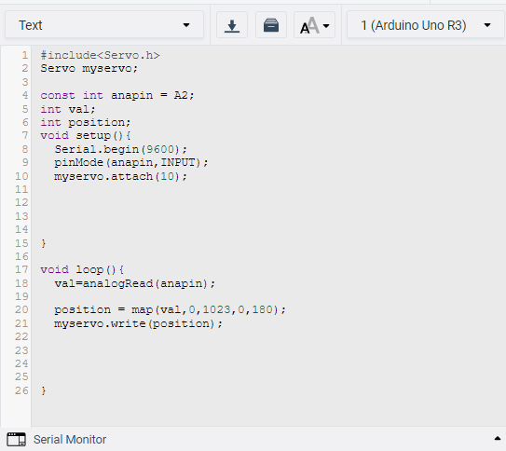

EXPERIMENT-8

Ultrasonic sensor with Buzzer and LED

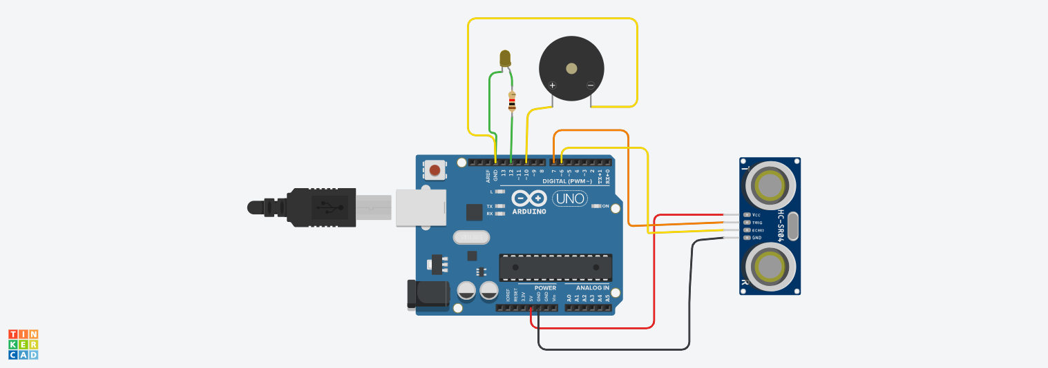

CODE:-

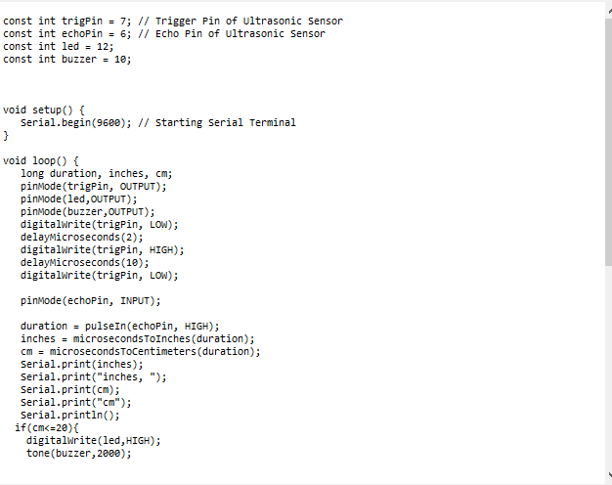

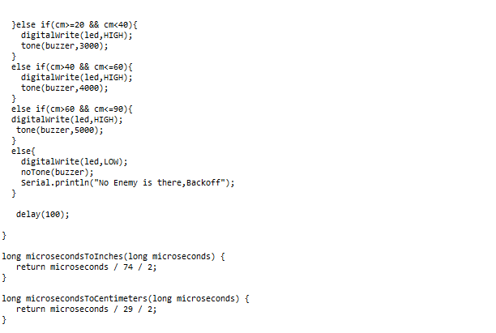

EXPERIMENT-9

DC MOTOR WITH PUSHBUTTON

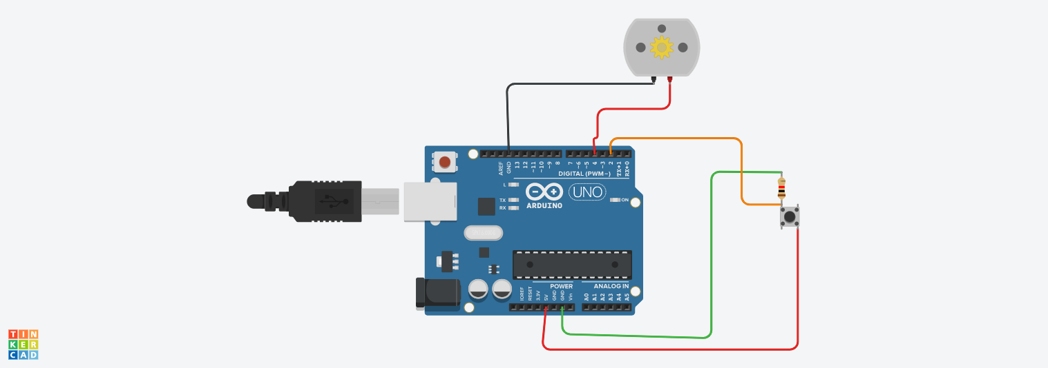

CODE:-

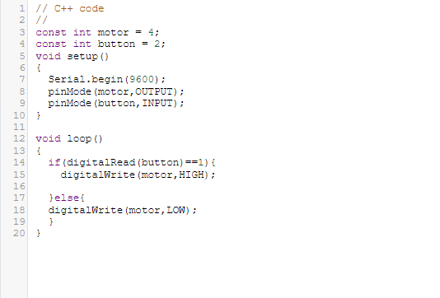

EXPERIMENT-10

Servo Motor With multiple LED'S

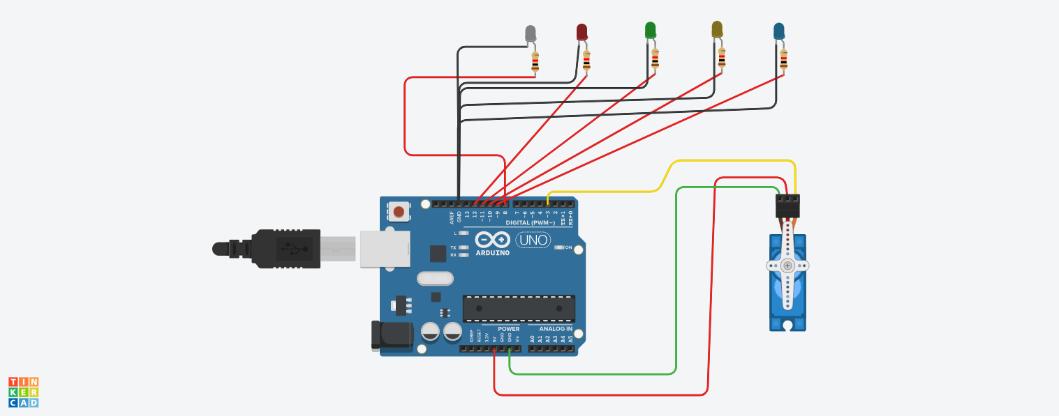

CODE:- 